Request you to restore Alle EPC Data base (AMP Energy) on AMP Energy Azure server.

Data Based from :
Alle Azure Server- 192.168.0.35
DB Name- AMP_Energy (PFA)

Data Based To :
S.No. Hostname Private IP Domain name
1 AMP-DEVSRV01 172.16.1.5 ampenergy.com
Application Server : 192.168.0.81

Following users are required.
Alletech Users
NAVUSER1 - Existing
NAVUSER2 - Existing
NAVUSER3
NAVUSER4

AMP ENERGY users
AMPUSER1
AMPUSER2
AMPUSER3
AMPUSER4

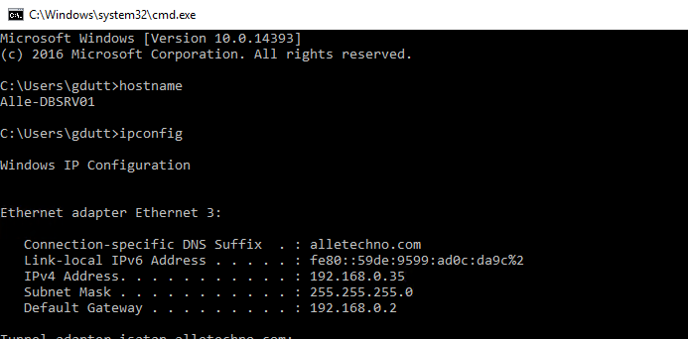

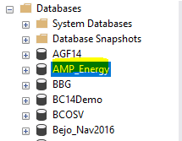

Take the Backup Up..

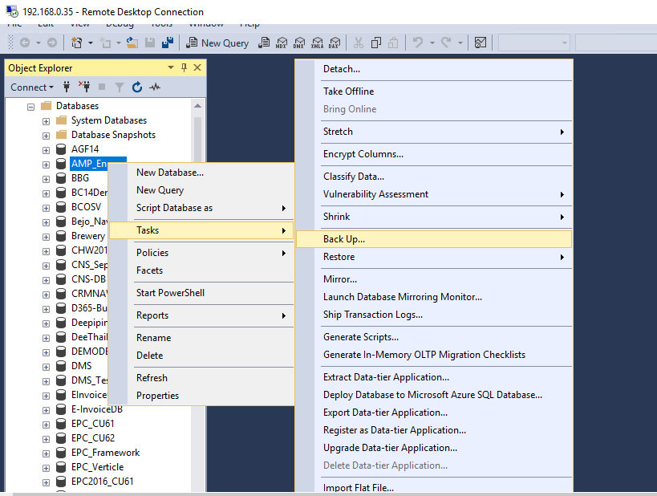

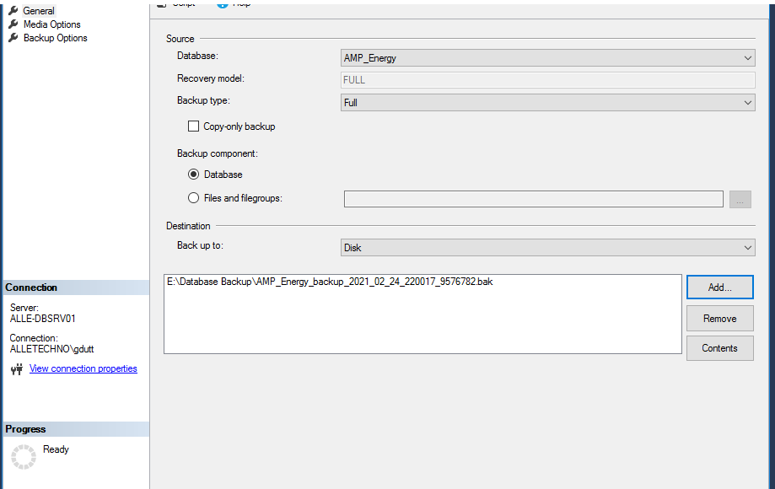

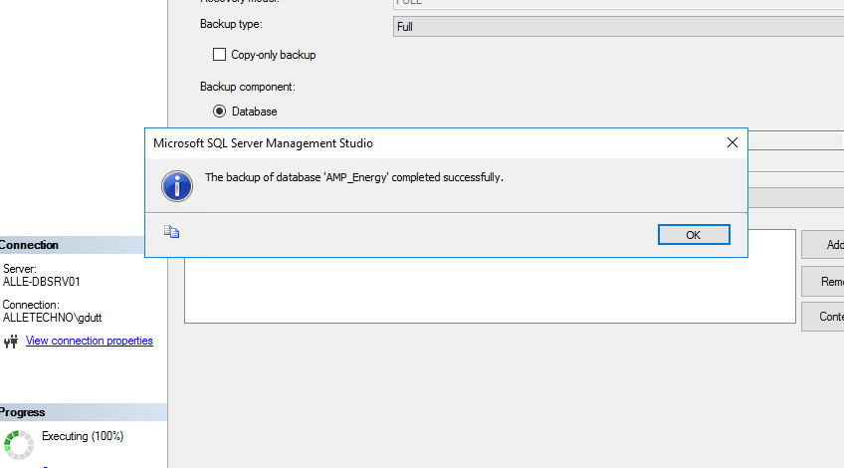

Take the backup Successfully

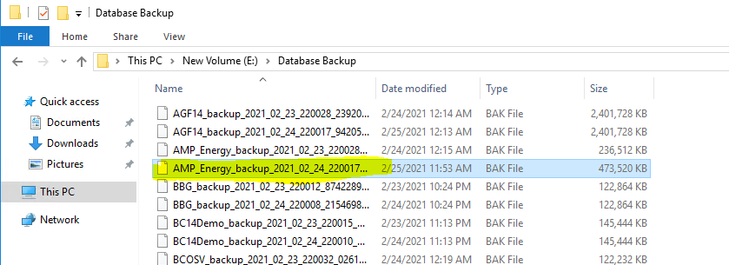

First of all I have Copied new database and Created two folder.

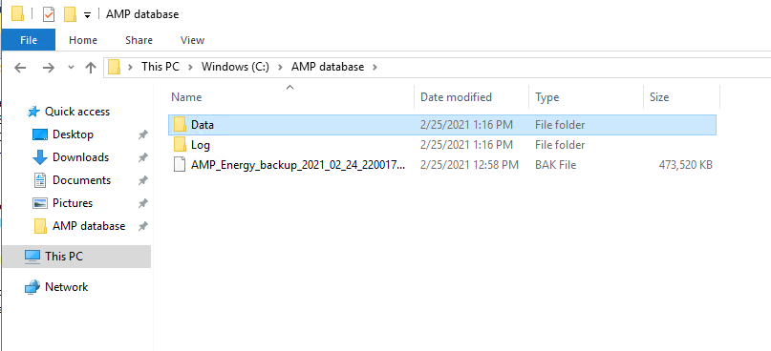

Right click on AMP Server Database

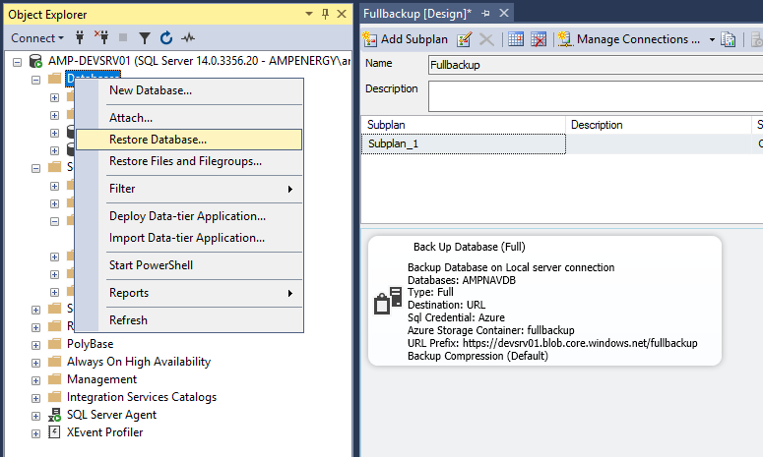

Click on Device
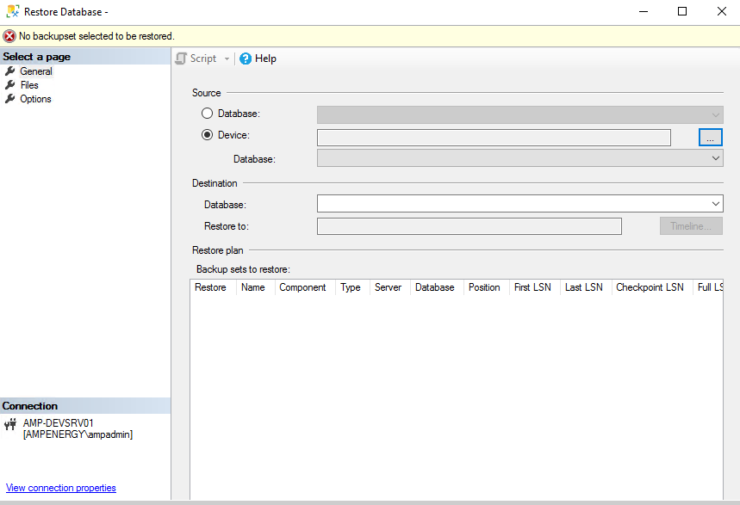

Find restore database

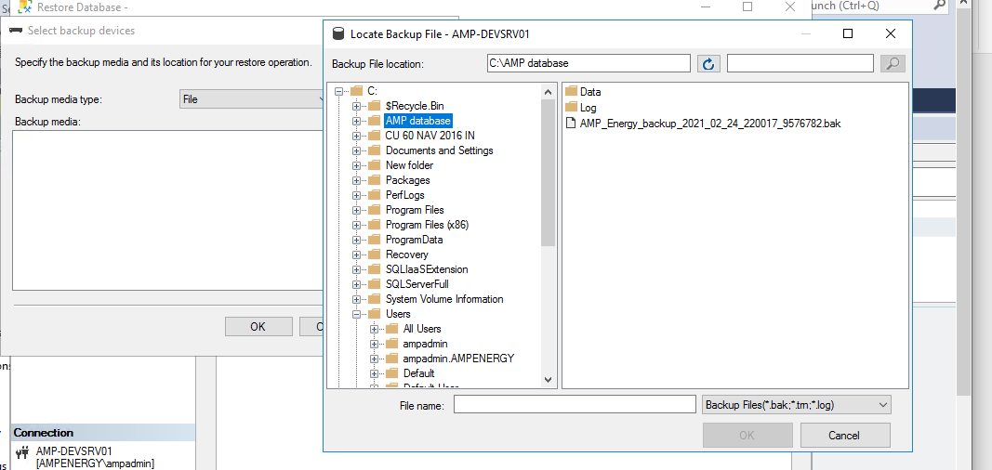

Click on file

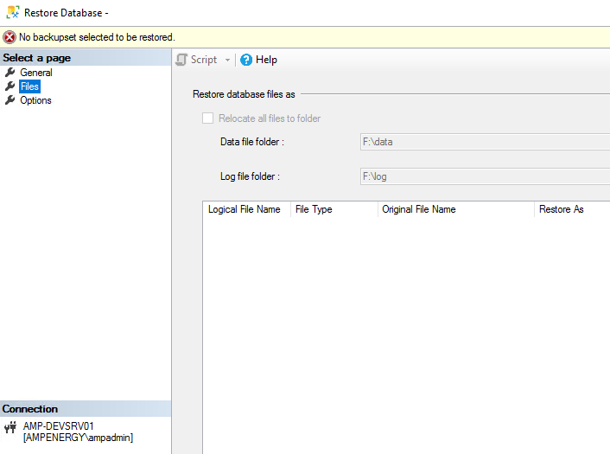

Define Data and log path…..
